Health and Safety Checklist for Teaching Staff Temporary Home Working

Incorrect use of Display Screen Equipment (DSE) or poorly designed workstations or environments can lead to:
- Musculo Skeletal Problems, e.g. Repetitive Strain Injury (RSI) which can affect any of your limbs. Slight pains ignored will develop and can lead to disability.
- Eye problems: blurred vision, caused by excessive use of screens, dry eyes (you may be entitled to free eye tests).
- Stress; headaches, tension, anxiety, lack of support etc.
Therefore, we suggest you consider the following points to minimise your risks whilst working from home.
The Chartered Institute of Ergonomics and Human Factors has published infographics(PDF) to help people working at home.
The HSE have published some guidance taking account of working arrangements during the Coronavirus (COVID-19) HSE Guidance for home workers

Working on a laptop
- Take regular postural breaks every 30 minutes or so, get up and stretch and walk around
- Exercise you wrists arms and shoulders
- Get up and walk around at least once an hour
- Rest your eyes frequently – refocus/look into the distance and remember to blink
- Keep hydrated – try to have a glass or bottle of water with you.
- Remember to take proper breaks away from your workstation – such as lunchtimes etc.

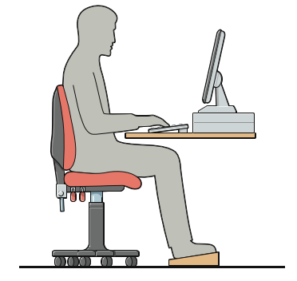
Item | Chair | Yes | No | Poss. Actions | Completed
1 | Can the height; seat and back of chair be adjusted to achieve the posture outlined in the diagram above?
2 | Are your feet supported fully when you are seated?
3 | Is your lower back supported?
4 | If you have armrests, can you still get close to your workstation
Keyboard and Mouse
1 | Are your elbows and forearms level with the work surface as outlined in diagram above?
2 | Is the keyboard close to the front edge of the desk allowing space for the wrist to rest on the desk surface?
3 | When using keyboard are wrists straight and upper arms relaxed?
4 | Do you need an external keyboard or monitor?  This would only be required if you are working for long periods of time
Laptops and other electrical equipment
1 | Has any School provided electrical equipment been inspected by a competent person? e.g. PAT Testing
2 | Are your fixed electrical sockets in good repair?
3 | Are laptop screens and keyboards suitable for prolonged use?
4 | Is there enough space to enable you to carry out your work safely?
5 | Is there adequate space for storage and use of work materials and equipment?
6 | Are you able to adjust your monitor/laptop height at just below eye level as outlined in the diagram above?
7 | Is the laptop screen/monitor and work surface free from glare?
Work Environment
1 | Are there any trailing wires around the work area?
2 | Is there enough natural light and ventilation to make your work area and activities safe and comfortable?
3 | Are floor coverings in good condition?
4 | Are levels of noise comfortable?
Other issues
1 | Have you notified your home insurance provider that you will be undertaking work from home?
2 | Have you got regular contact with your Headteacher/Line manager?
3 | Are you aware of how to report any work-related health issues, accidents or incidents whilst working from home?
4 | Have you got a buddy system established?
5 | Are you aware of the Employer Assistance programme for mental health and emotional wellbeing support?
6 | Eye tests Under the DSE regulations, users have a right to eye tests upon starting computer work and at regular intervals after, at the employer’s expenses. Where tests show that the user requires special glasses or lenses for computer work, the employer must pay for the cost of a basic pair.
Pregnant women
1 | Are you aware of the need to adapt your workstation as your needs change?
2 | Working safely with DSE - Pregnancy or Epilepsy
Do you have any other comments about your working conditions or any other health and safety concerns? (Please specify)

Employee Name |  | Date
Signature
Line Manager Name |  | Date
Signature

